Title: Short and Concise, no more than 15 words

Author Name ^{1*}, Author Name ² (Use 1, 2 If Department or University Name Is Different)
¹ Departments, University, Regions, Countries
² Departments, University, Regions, Countries
Email: uthor@gmail.com, uthor@gmail.com ² (Make sure all author's emails are written)

*Corresponding author: e-mail auhtor

Article History  Revised:  Accepted:  Published: | Abstract: Abstract is written in one paragraph using standard Indonesian with improved spelling. The average word count should be 150-250 words. Contains a brief overview of the overall research results including the background of the problem, objectives, methods, results and conclusions. Avoid writing bibliographic citations, as well as abbreviations in the abstract. Abstract contains the title of the article, research object, objectives, methods and results. Palatino Linotype font size 9pt, space 1  Keywords: write 3-5 keywords, separate them with a semicolon (;) between them

Introduction
The Introduction section should provide a concise yet comprehensive background on the topic to highlight its relevance and urgency. It should clearly state the main issue while avoiding overly detailed explanations of the theory. A brief review of the relevant literature is necessary to position the research in existing research and to indicate any gaps or needs that this paper seeks to address. References should be cited in parentheses using the format (author, year).
Furthermore, this section should present the proposed approach, idea, or solution, emphasizing the contribution of the research activity, both academically and practically. The introduction should end with a clear statement of objectives, outlining the direction of the paper and the expected outcome.
The introduction answers why the research or study is carried out what previous researchers have done or scientific articles that are now developing, problems, and objectives. Writing in a narrative manner does not need to be given a special sub-title. Included in the writing of operational definitions, if deemed necessary, is also written narratively. [Palatino Linotype font 11pt and 1 space]

Research Methods
The research method contains the type of research, the sample and the population or subject of the research, the time and place of the research, the instruments, procedures and techniques of the research, and other matters related to the method of research. The research method is described in detail which contains the design, population, sample and sampling technique, how the research works, the parameters observed, the description of the variables used, and the technical analysis. The method is written in the form of a narrative by conveying the important ways in which the research is conducted. Any form of instruction, manual or technical manual in research activities that are too detailed should not be included. [Palatino Linotype font 11pt and 1 space]

Results and Discussion
The Results and Discussion sections should provide an objective description of the findings and should be aligned with the objectives of the service activities. The discussion should be supported by relevant references and bibliographic sources. Results may be presented in the form of images, tables, or other visual aids to improve reader understanding. Both qualitative and quantitative analyses should focus on addressing the research problem. This section should comprehensively describe the activities undertaken, including the underlying concepts, design, hypotheses (if any), experiments, observational data, and analysis.
This section describes the results and discusses the results obtained from the research and draws similarities and differences between previous studies of methods, data and results. However, explain whether the problem has been successfully researched according to the objectives of using the proposed method. This should involve a description of the analysis performed, the causes and benchmarks of success/failure, and the part of the steps to be taken as a follow-up process. [Palatino Linotype font 11pt and 1 space]
The content is supported by the images, tables, and equations referenced in the text.

Table
Make sure each table has a sequence number and title. The table is left aligned. Also pay attention to the font used in Table 1.

Table 1. Table titles, use Sentence Case (originally capitalized) ) [Palatine Font Linotype 9pt]
Yes | Rows | Bold
1. | Table contents | Table contents
2. | Table contents | Table contents

Table 2. Table title, use sentence case (capital initials)
Problem | Solution | Output
There is no standard for organizing teaching and learning activities in blended or online learning systems. | Assistance in the preparation of standard operating procedures for blended learning implementation | SOP KBM
Non-optimal use of teleconference media and teaching materials in online learning. | Needs analysis and clear SOPs for the provision/preparation of teaching materials | SOP for the preparation and use of teaching materials

The content of the table, if it is not sufficient, you can reduce the font size to 9 fonts. Try not to cut the table on different pages, unless it is larger than one page. If you have to cut out, don't forget to rewrite the row header for each column, give the table sequence number the same, and replace the title with Advanced. Table titles do not end with a period. For tables with a width of more than 1 column, they must be placed at the beginning or end of the page, while tables with a width of less than 1 column are free placement as long as they are placed after the sentence that refers to them.

Image
As with tables, make sure each image has a sequence number and a title. Make the image you use look professionally made and doesn't need to be framed. Make sure to use a greyscale image. Use the Image Title style for this format. The image is center-flat. The image title does not end with a period. For images with a width of more than 1 column, the position of the image should be placed at the beginning or end of the page, while images with a width of less than 1 column should be placed freely. However, images with this small size should not be placed before the sentence that refers to them, especially if they are placed before the title of the paper.

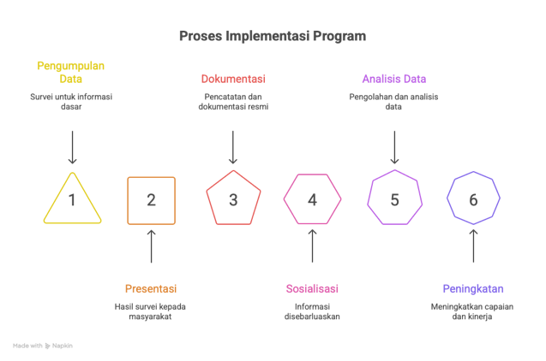
Figure 1. Image title, also using sentence case (capital initials) [Palatino Linotype 9pt font]

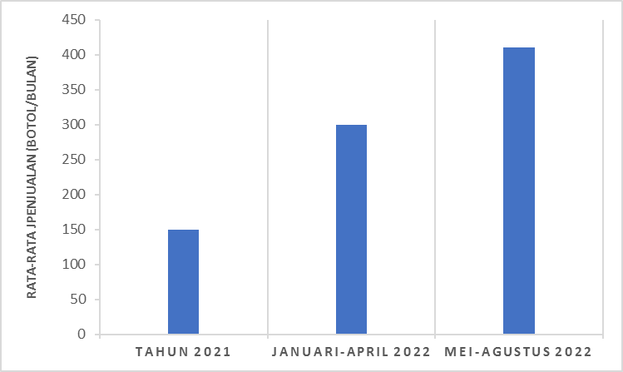
Figure 1. Increase in Sales of Herbal Products

Conclusion
This section involves summarizing the findings without adding new information from what was already stated in the previous section. However, it should not be a word-for-word repetition of what has been discussed in the results and discussion sections.
Deductions or conclusions are made from the previous description with the addition of argumentative personal opinions. It should also include the limitations of the research in the process, the theories used. The methods applied, or generalizations of the results that will serve as the basis for further research on the subject that serves in response to the observed limitations. In addition, the implications of this study should also be included.

References
References should contain at least 20 references that refer to the primary source and include links to indicate the references are accessible. Avoid using sources from similar websites or pages that do not have reliable scientific sources. The title of the reference section above is not numbered. You can easily create this format with the help of the EndNote, Mendeley, or Zotero applications. If this application is not available on your computer, it is not difficult to use the format in the example below (APA Style). For all authors, write the last name followed by the abbreviated middle and front name. Only published papers (book title, journal name and volume number) are italicized. Note that for references from the Internet, all reference sections are still written in full. Here is an example of writing a reference.
The reference list is organized in the following example and sorted alphabetically:

Ahmad Khotim, D. d. (2014). Analysis of Optimal Portfolio Formation using Single Index and Stochastic Dominance Models. Journal of Business Administration.
Afrizal, R., Tenofrimer, & Arma, D. (2025). Integrating the Correctional System into Criminal Procedural Law : An Analytical Study on the Urgency of Legal Reform. Ekasakti Journal of Law and Justice, 3(2), 110-119. https://doi.org/10.60034/w26a8882
Amanah, S. (2007). The Meaning of Counseling and Human Behavior Transformation. Journal of Counseling, 3(1), 63–67. https://doi.org/10.25015/penyuluhan.v3i1.2152
Aniuranti, A., Tsani, M. H. N., & Wulandari, Y. (2021). Training on the preparation of Ice Breaking to strengthen the competence of prospective teachers. ABSYARA: Journal of Community Service, 2(1), 85–93. https://doi.org/10.29408/ab.v2i1.3578
Anwar, M. R. (2019). Early Childhood Teachers and Public Speaking Skills in the MEA Era. Lonto Leok Journal, 2(1), 56–61. http://unikastpaulus.ac.id/jurnal/index.php/jilpaud/article/view/338/227
Bank Indonesia. (2012, May 25). Retrieved from http://www.bi.go.id
Budaraga, I. K., & Devi, W. S. (2021). Community Service Improving the Quality of Asyifa Souvenir Taro Chips Business. Proceedings of the National Seminar on Community Service, 1(1), 172–180. https://jurnal.fp.uns.ac.id/index.php/pengmas/article/view/1963
Desnirita, D., & M. Adil Abdurrahman. (2023). The Influence of Leadership Style, Work Discipline, and Work Spirit on Employee Performance in the State Printing Public Company of the Republic of Indonesia. Journal of the Indonesian Academy of Accounting Padang, 3(1), 1-17. https://doi.org/10.31933/jaaip.v3i1.857
Hapsari, L. C. (2013). Analysis of Optimal Portfolio Formation Using the Markowitz Model for LQ-45 Stocks for the Period 2008-2012. Journal of Management.
Harefa, A. (2007). To Make Writing-Composing Easy (4th ed.). Gramedia Pustaka Utama. https://books.google.co.id/books?id=-DliaG-3C64C&dq
Hartono, J. (2013). Portfolio Theory and Investment Analysis. Yogyakarta: BPFE-Yogyakarta.
Husnan, S. (2005). Fundamentals of Portfolio Theory and Securities Analysis. Yogyakarta: AMP YKPN.
Ibiz Coach. (2018). This is the Difference Between Mentoring, Consulting, Training, and Coaching. https://ibizcoach.com/perbedaan-mentoring-consulting-training-dan-coaching/
Ministry of Education and Culture. (2019). Regional Education Balance: Teacher Competency Test Data. Ministry of Education and Culture. https://npd.kemdikbud.go.id/?appid=ukg,
Mallapiang, F., Kurniati, Y., Syahrir, S., Lagu, A. M. H., & Sadarang, R. A. I. (2020). Waste management with an Asset-Based Community Development (ABCD) approach in the coastal area of Bulukumba, South Sulawesi. Riau Journal of Empowerment, 3(2), 79–86. https://doi.org/10.31258/raje.3.2.79-86
Nalhadi, A., Syarifudin, S., Habibi, F., Fatah, A., & Supriyadi, S. (2020). Community Empowerment in the Utilization of Household Waste into Liquid Organic Fertilizer. Wikrama Parahita : Journal of Community Service, 4(1), 43–46. https://doi.org/10.30656/jpmwp.v4i1.2134
Nurgesang, F. A., & Ridlwan, P. P. M. (2019). The Manufacturing of Banana Cutting Machine for Making Chips with Capacity of 35 kg/h to Improve Productivity of a Home Industry in Putat Village, Gunungkidul, Yogyakarta. Proceedings of SNTTM XVIII, 1–7. http://prosiding.bkstm.org/prosiding/2019/TM11.pdf
Oktaviana, F., Hanidian, O., Aji, B. S., & Baihaqi, I. (2020). Online-Based Village Administration Services in Paremono Village. ABDIPRAJA (Journal of Community Service), 1(1), 49–56. https://doi.org/10.31002/abdipraja.v1i1.3205
Palenti, C. D. (2021). Improving Communication Skills through Participatory Learning in Community Empowerment Activities. Diklus: Journal of Out-of-School Education, 5(1), 87–98. https://doi.org/10.21831/diklus.v5i1.37074
Permana, E. P. (2021). The Influence of Paper Puppet Learning Media on the Character Values of Elementary School Students. Prima Magistra: Scientific Journal of Education, 2(2), 190–196. https://doi.org/10.37478/jpm.v2i2.1028
Prastyan, R. D. N. (2019). Strengthening Character Education of Elementary School Children Through the Concept of Learning Based on Regional Cultural Arts and Traditional Games in Kampoeng Dolanan Nusantara Borobudur Magelang. National Seminar on National Basic Education Performance (PPDN), 1(1), 93–101. http://www.seminar.uad.ac.id/index.php/ppdn/article/view/1446
Yuwanita, E. (2016). The Effectiveness of the Use of Learning Video Media to Improve Student Learning Outcomes in the Basic Subjects of Sewing Technology at SMK Negeri 3 Pacitan. Thesis. Semarang: Semarang State University. http://lib.unnes.ac.id/28353/1/5401411100.pdf

